How to Troubleshoot When There Is Something Wrong with the Alarm Notifications on EZView?
How to Troubleshoot When There Is Something Wrong with the Alarm Notifications on EZView?
Description
Note: This method is applicable to most of the scenarios, if the method still cannot solve your problem, it is recommended to consult our Tech Support Team.
https://global.uniview.com/Support/Service_Hotline/
Operating Steps
First scenario:
The cellphone receives the alarm notification banner, but upon opening the app, no records are found under Alarm Notifications.
Step 1 Check the time settings of the app/mobile phone and the Uniview device
Differences in time between your mobile phone and the Uniview device could potentially cause alarm notification issues. Therefore, if the Uniview device's time doesn't match the local time, it's essential to synchronize the device's time accordingly.
If both your phone and the Uniview device share the same time zone, manually synchronize the device time with your mobile phone through EZView. Navigate to Device Config>Settings>Time to perform the synchronization.
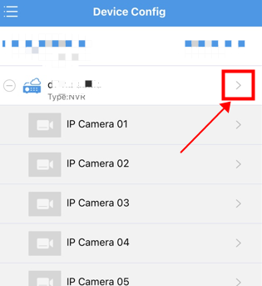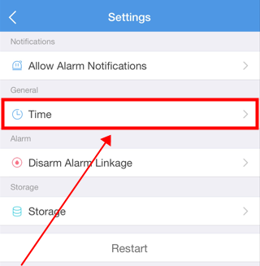
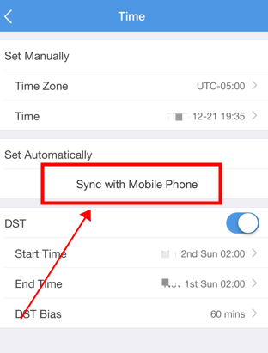
If your Uniview device is located in a different time zone, please confirm and adjust the device's settings to accurately reflect the local time at its installation site.
Step 2 Check the hard disk status in the Uniview device
The absence of records under Alarm Notifications on EZView might be due to malfunctioning or abnormal hard disks in a Uniview device. Therefore, please refer to the provided document below to verify the status of the hard drives in the Uniview device either on the web page or within the GUI/monitor:
https://global.uniview.com/Support/FAQ/NVR/202308/974472_168459_0.htm
Step 3 Check the alarm logs from your Uniview NVR
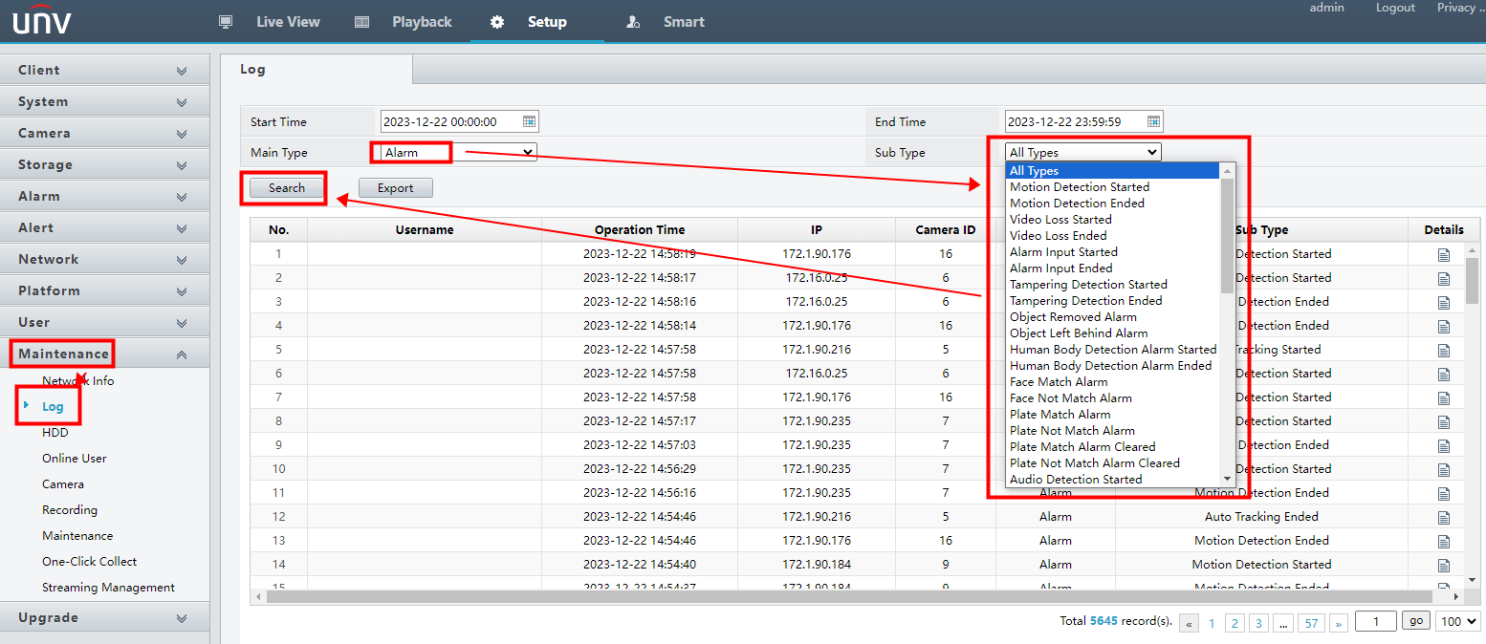
Alarm records within a Uniview NVR's log must exist for us to access the relevant alarm records through the EZView app's Alarm Notifications feature after receiving an alarm banner notification.
In the event of no alarm records present in the Uniview NVR's log, please verify and ensure that the alarms are correctly configured and set up on the NVR.
Second scenario:
The cellphone CANNOT receive any alarm notification banner, but upon opening the app, alarm records are found under Alarm Notifications.
Step 1 Failure to activate the notification function within the EZView app may result in missing alarm banners on your mobile phone. Therefore, please check and ensure that the notification feature of your EZView app is turned on under Me>General>Push Notification Settings>Allow Notifications
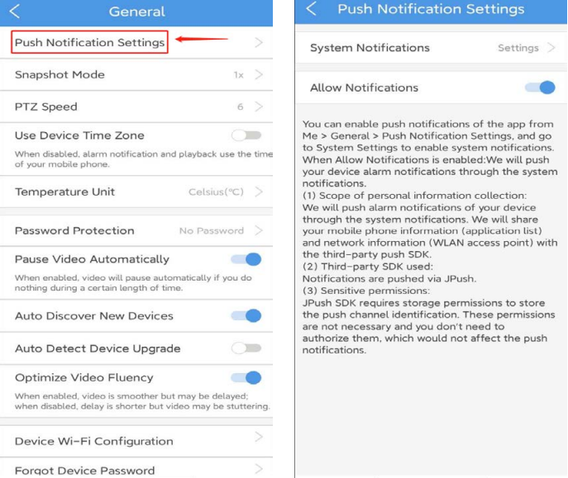
Note: Alarm push is available to cloud devices and devices added without signup. It is not available to local devices or devices adding through IP/domain or DDNS manually.
Step 2 If your mobile phone doesn't grant notification permissions to the EZView app, you won't receive a banner when there's an alarm notification within the app. Therefore, please navigate to Me>General>Push Notification Settings>System Notifications>Settings on the EZView app to ensure that the notification permissions for the EZView app on your mobile phone have been enabled.
Here are instructions on enabling notification permissions for an app on both a Samsung Android Phone and iPhone for your reference.
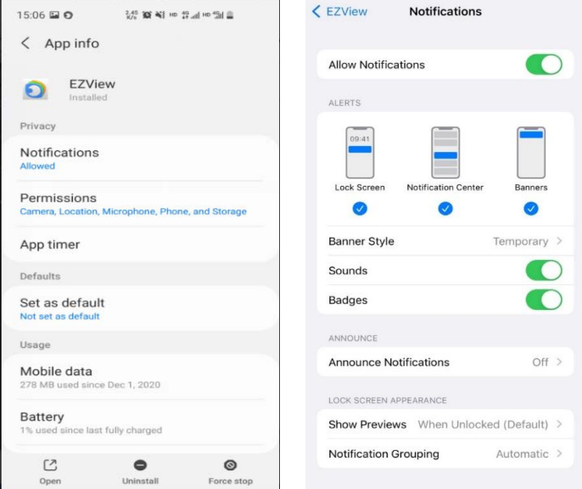
Step 3 Turn on the Alarm Notifications for certain cameras or NVRs from EZView App under Me>Alarm Notifications>Allow Notifications and then set up the detailed settings such as alarm channel, time and type accordingly under Me>Alarm Notifications>Allow Notifications>Advanced Settings.
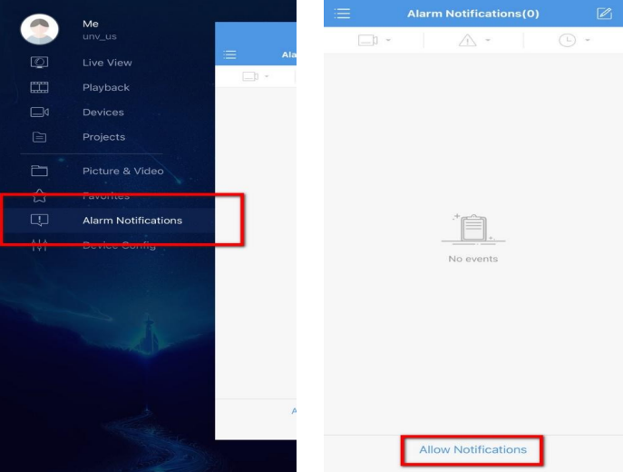
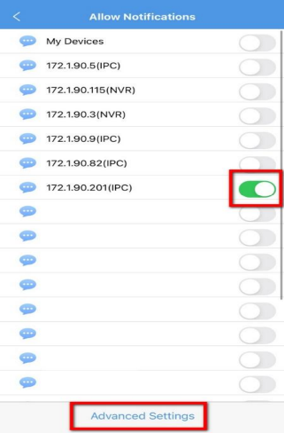
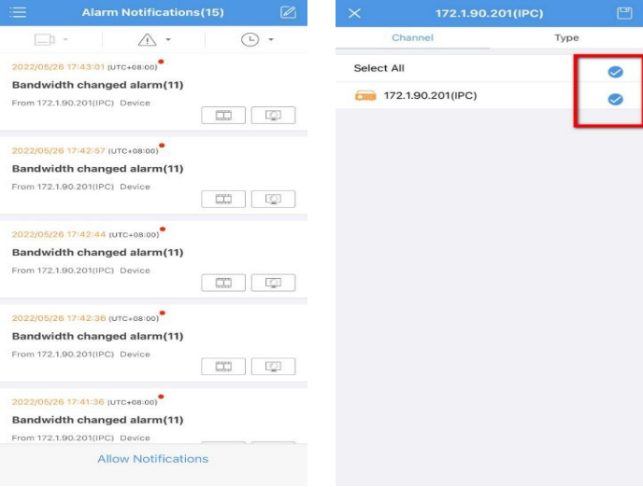
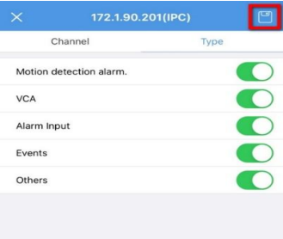
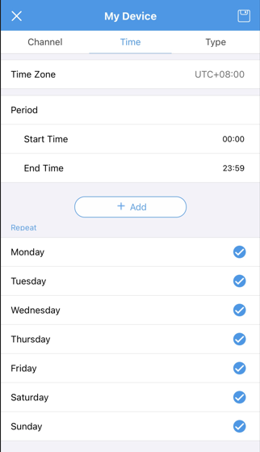
Step 4 Go to Device Config, click on the device you need to turn the alarm notifications on and then turn on Allow Alarm Notifications.
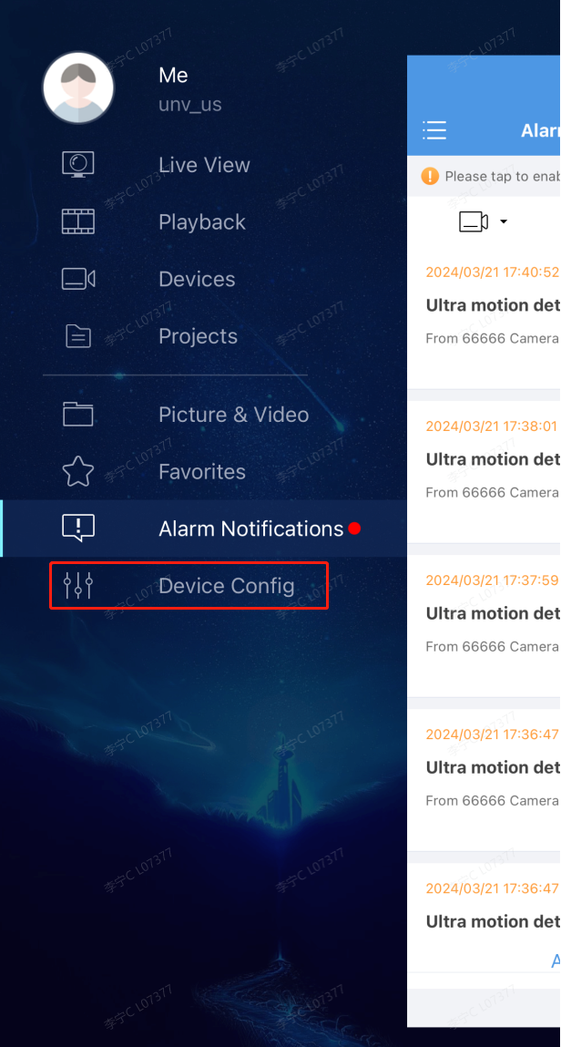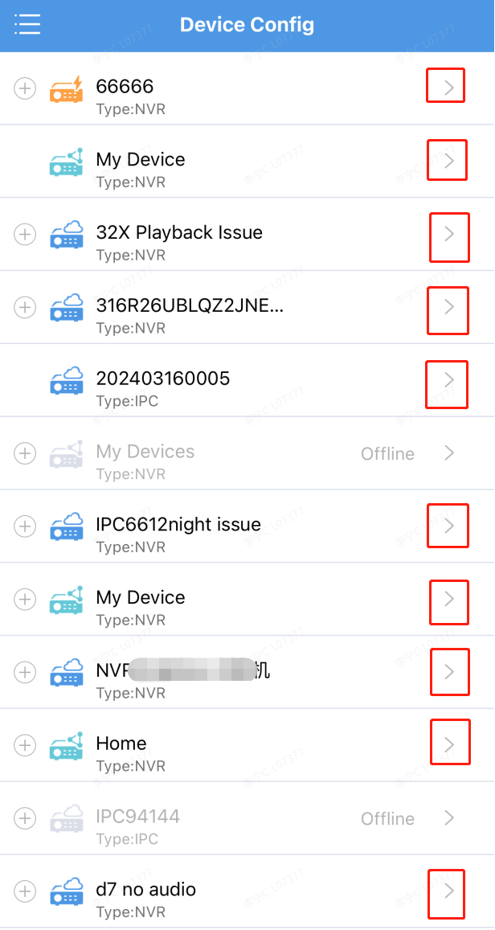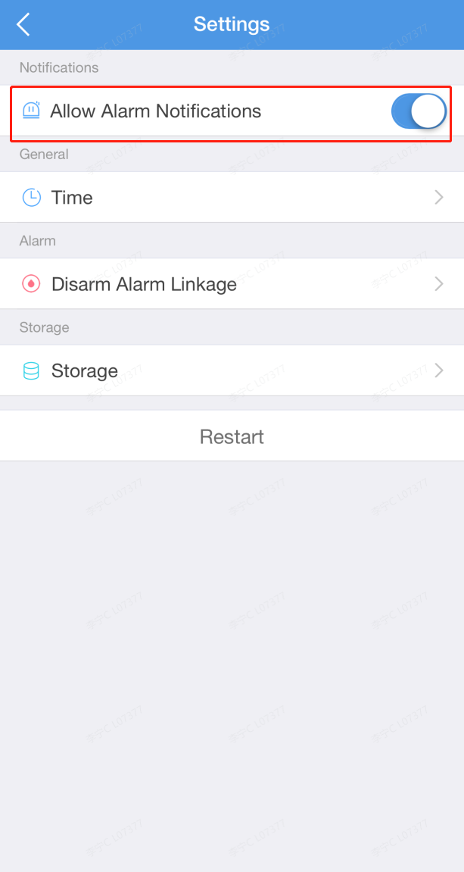
Step 5 If after confirming all the aforementioned settings without finding any mistakes, and you're still not receiving alarm banners, proceed to check the alarm trigger action settings of your camera on the Uniview NVR. Ensure that you have enabled the Push Alarm function within the alarm trigger actions for the previously set up alarm.
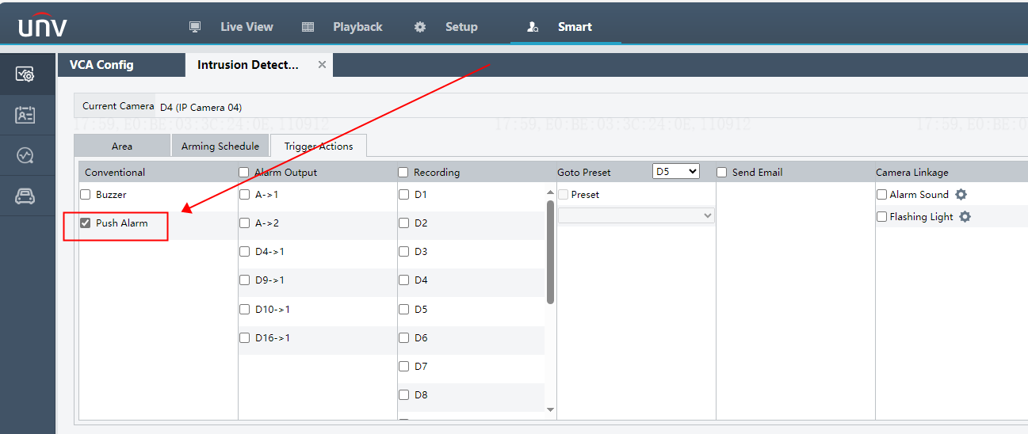
If the issue persists despite following all the troubleshooting steps mentioned earlier, please contact the Uniview tech support team for further assistance.
https://global.uniview.com/Support/Service_Hotline/

